MISSING PERSON
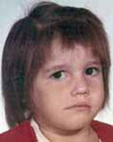
Sherry Lynn Young
Missing since June 1, 1984 from Orlando, Orange County, Florida
Classification: Endangered Missing
Vital Statistics
- Date Of Birth: August 26, 1970
- Age at Time of Disappearance: 13 years old
- Distinguishing Characteristics: White female. Brown hair; brown eyes.

Circumstances of Disappearance
Sherry Young was last seen in Orlando on June 1, 1984.

If you have any information concerning this case, please contact:
Orange County Sheriff's Office
407-254-7012
Sponsored by For the Lost – California Kids program
www.ForTheLost.org

