MISSING PERSON
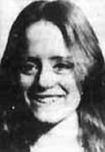
Susan Curtis
Missing since June 27, 1975 from Provo, Utah County, Utah
Classification: Endangered Missing
Vital Statistics
- Date Of Birth: May 18, 1960
- Age at Time of Disappearance: 15 years old
- Distinguishing Characteristics: White female. Light brown hair, hazel eyes.
- Dentals: Braces.
- AKA: Sue.
- Clothing: Yellow evening gown.
Circumstances of Disappearance
Sue Curtis was last seen at the Brigham Young University Campus in Provo, where she was attending a youth conference. Serial Killer Ted Bundy confessed to her homicide prior to his execution.
If you have any information concerning this case, please contact:
Brigham Young University Police
801-422-4051
Sponsored by For the Lost – California Kids program
www.ForTheLost.org

