MISSING PERSON
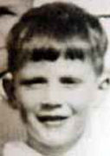
Howard Newell
Missing since January 22, 1955 from Yarmouth, Nova Scotia, Canada
Classification: Endangered Missing
Vital Statistics
- Age at Time of Disappearance: 6 years old

Circumstances of Disappearance
On January 22, 1955, Howard Newell vanished while walking home from a woodlot where members of his family were cutting firewood. In the days and weeks that followed, the largest search in Yarmouth County history unfolded in the woods and marsh areas of Little River Harbour. More than 1,000 searchers scoured the area searching for the little boy, but there was never any trace of him.
If you have any information concerning this case, please contact:
Yarmouth Rural RCMP
902-742-9106
Sponsored by For the Lost – California Kids program
www.ForTheLost.org

