MISSING PERSON
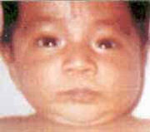
Efrain Baez Suarez
Missing since February 25, 1998 from Apisco, Tlaxcala, Mexico
Classification: Non-Family Abduction
Vital Statistics
- Age at Time of Disappearance: 2 months old
- Distinguishing Characteristics: Hispanic male. Black hair; brown eyes.

Circumstances of Disappearance
Efrain was abducted by a woman disguised as a nurse in the town of Yahuquemecán, on February 25, 1998.
If you have any information concerning this case, please contact:
PGR
01-800-002-5200
Sponsored by For the Lost – California Kids program
www.ForTheLost.org

