MISSING PERSON
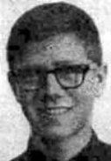
Darrel B. Nichols
Missing since April 1, 1973 from Park City, Summit County, Utah
Classification: Endangered Missing
Vital Statistics
- Date of Birth: October 7, 1955
- Age at Time of Disappearance: 17 years old
- Distinguishing Characteristics: White male. Brown hair; brown eyes.
- Medical: Horned rim glasses.

Circumstances of Disappearance
Nichols was possibly last seen with unknown friends in the hills of Park City.
If you have any information concerning this case, please contact:
Park City Police Department
435-615-5500
Sponsored by For the Lost – California Kids program
www.ForTheLost.org

