MISSING PERSON
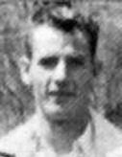
Alexander Whitehorne
Missing since October 11, 1964 from Cormack, Newfoundland, Canada.
Classification: Endangered Missing
Vital Statistics
- Age at Time of Disappearance: 17 years old

Circumstances of Disappearance
Whitehorne was last seen on October 11, 1964, leaving Cormack, Newfoundland to take a bus to Corner Brook. Foul play is suspected.
If you have any information concerning this case, please contact:
RCMP Corner Brook, Newfoundland
Criminal Investigation Division
Cst. Tom Earles
709-637-4111
Sponsored by For the Lost – California Kids program
www.ForTheLost.org

