MISSING PERSON
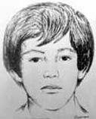
Adrian Calderon Uribe
Missing since September 15, 1993 from Iztalapa, Distrito Federal, Mexico
Classification: Endangered Missing
Vital Statistics
- Age at Time of Disappearance: 9 years old
- Distinguishing Characteristics: Hispanic male. Straight black hair, black eyes. Dark brown complexion.

Circumstances of Disappearance
Adrian Calderon Uribe was last seen at Colonia Juan Escutia, Iztalapa, MX.
If you have any information concerning this case, please contact:
Procuraduria General de la Republica
01-800-002-5200
Sponsored by For the Lost – California Kids program
www.ForTheLost.org

